React Native Environment Setup: A Step-by-Step Guide

System Requirements

**Operating System**: Windows 11 Home

**CPU**: AMD Ryzen 5 PRO 4650U

**RAM**: 16GB

**1. Installation Instructions**

**1.1 Install Node.js**

* **Download**: Visit [Node.js](https://nodejs.org) and download the latest stable version (LTS).
* **Install**: Follow the installer’s steps.
* **Verify Installation**:

**2. Project Creation**

Once the environment is set up, create a new React Native project by following these steps:

1. **Open Command Prompt** (or Terminal in VSCode).
2. Run the following command:

npx create-expo-app@latest – template

then follow this link: [https://docs.expo.dev/router/installation/#manual-installation](https://docs.expo.dev/router/installation/%23manual-installation)

Install dependencies:

npx expo install expo-router react-native-safe-area-context react-native-screens expo-linking expo-constants expo-status-bar

install the following dependencies for web:

npx expo install react-native-web react-dom

Running the Project: npx expo start -c

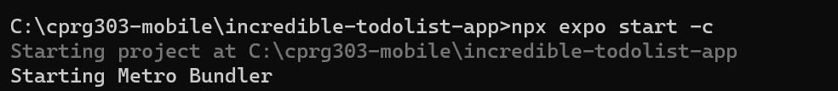

**3. Resources**

* **React Native Official Documentation**: https://reactnative.dev/docs/environment-setup
* **Node.js Official Website**: <https://nodejs.org>
* Install Expo Router: [Install Expo Router - Expo Documentation](https://docs.expo.dev/router/installation/#manual-installation)